**Laboratory work 2**

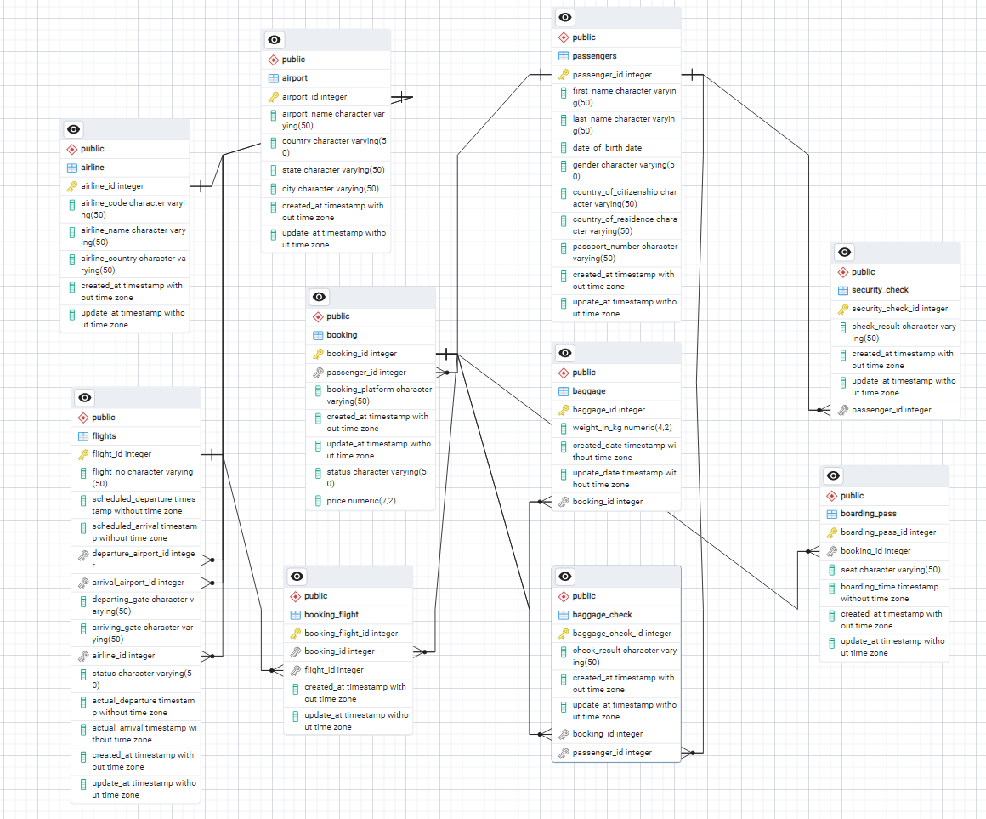

Make a relationship between following tables **(20%):**

- Passengers with Secuitiry_check, Booking, Baggage_check by passenger_id;

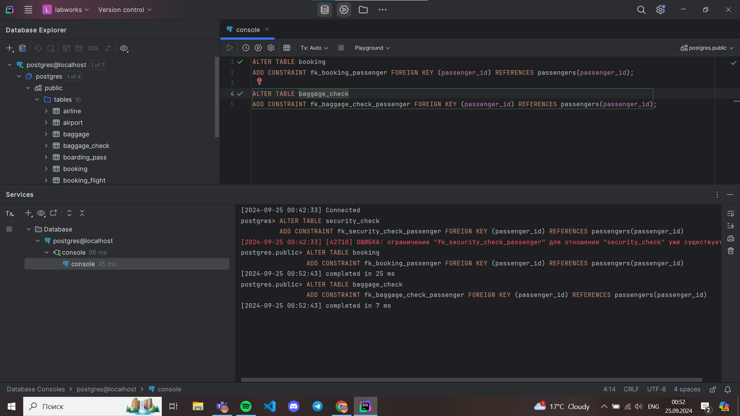

-Booking with Baggage_check, Baggage, Boarding_pass, Booking_flight by booking_id;

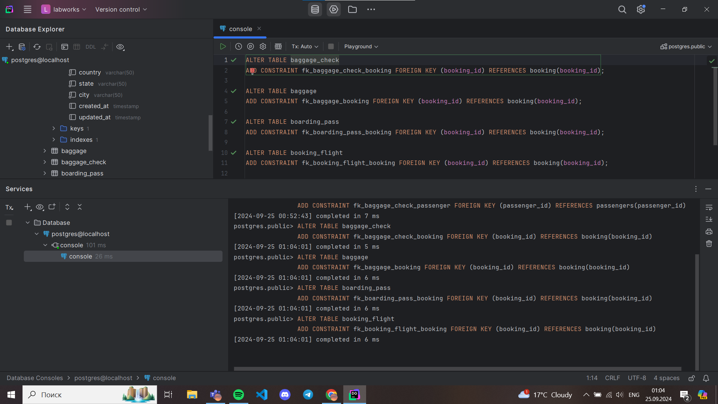

- Flights with Booking_flight by flight_id;

- Airport with Flights by departing_airport_id;

- Airport with Flights by arriving_airport_id;

- Airline with Flights by airline_id;

Next slide

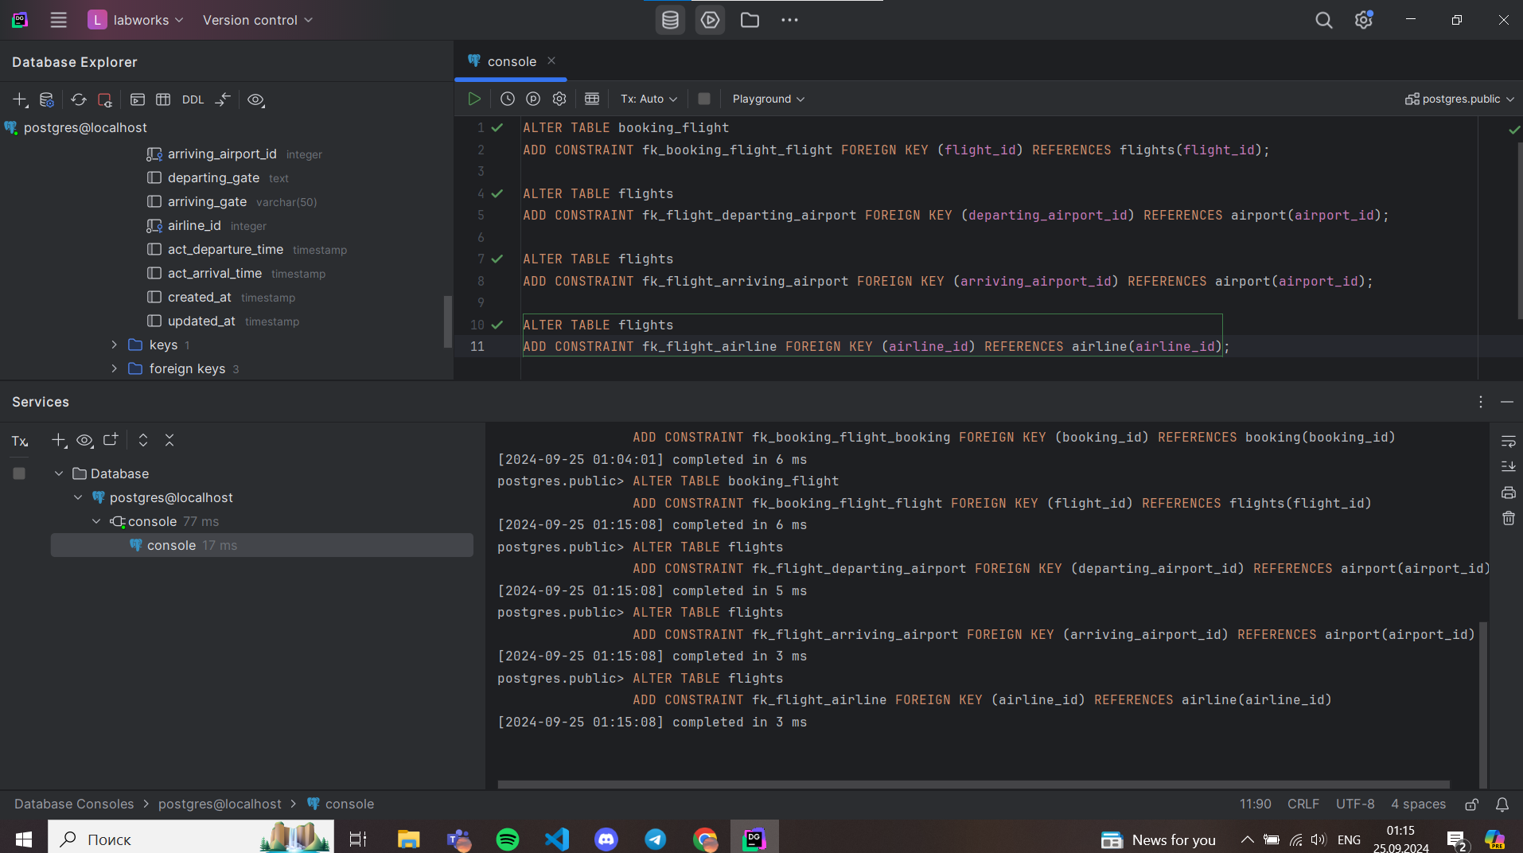

**DML – Data Manipulation Language**

1. Generate and insert 100 random rows in your airport database using mockaroo service ([https://www.mockaroo.com/).**(10**](https://www.mockaroo.com/).(10)**%)**  
   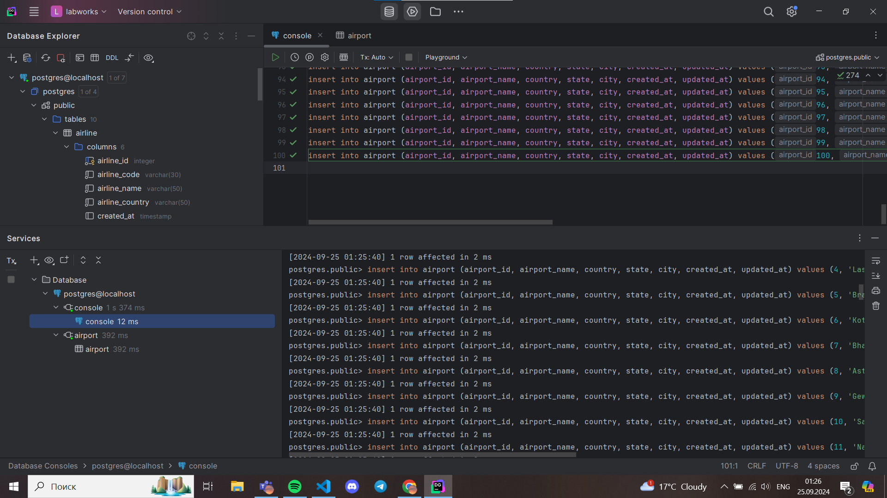  
   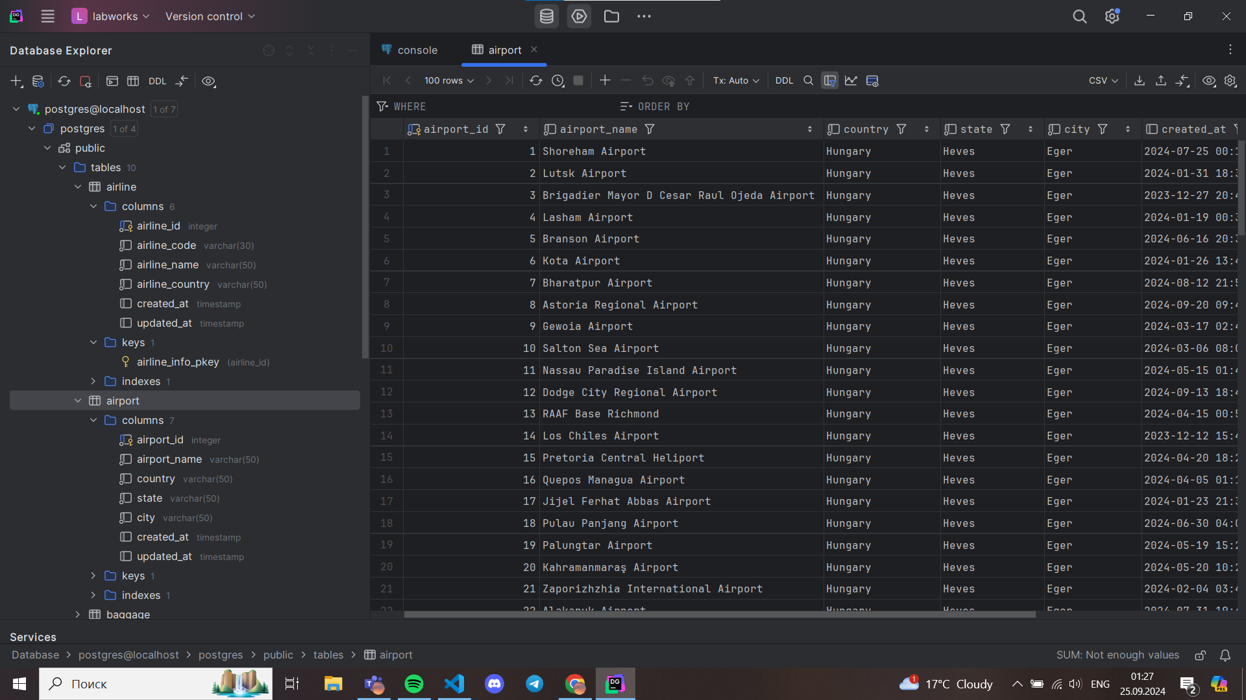
2. Add a new airline named "KazAir" based in "Kazakhstan" to the airline table.(**10%** )  
   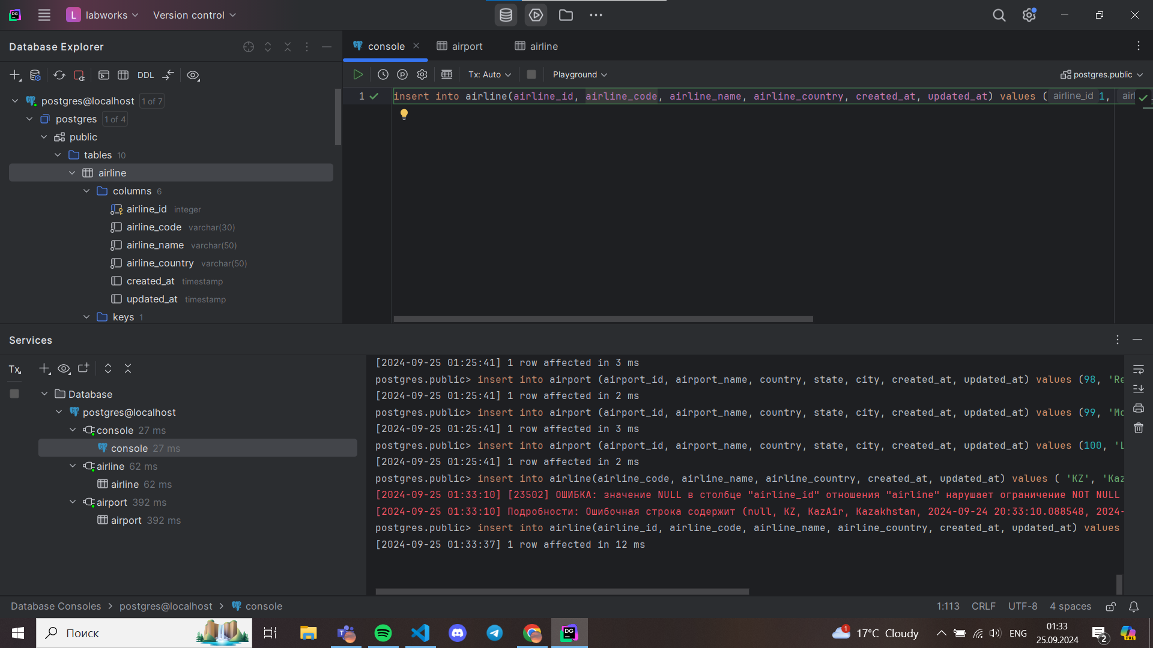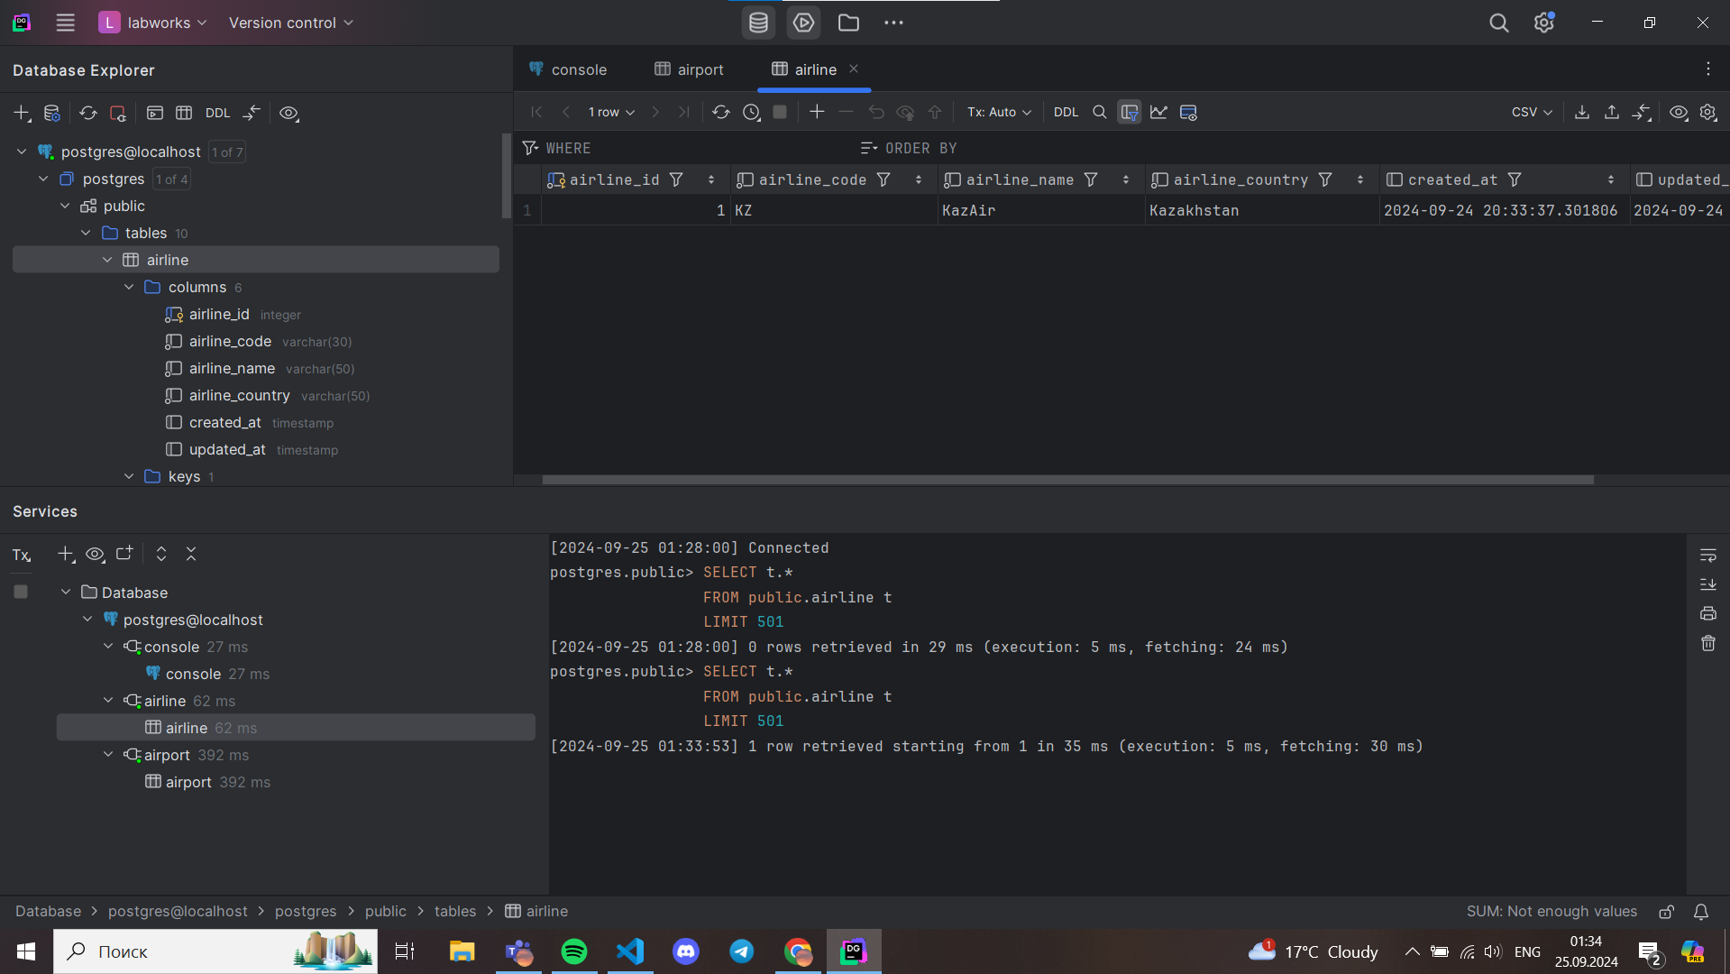
3. Update the airline country "KazAir" to "Turkey".(**10%** )  
   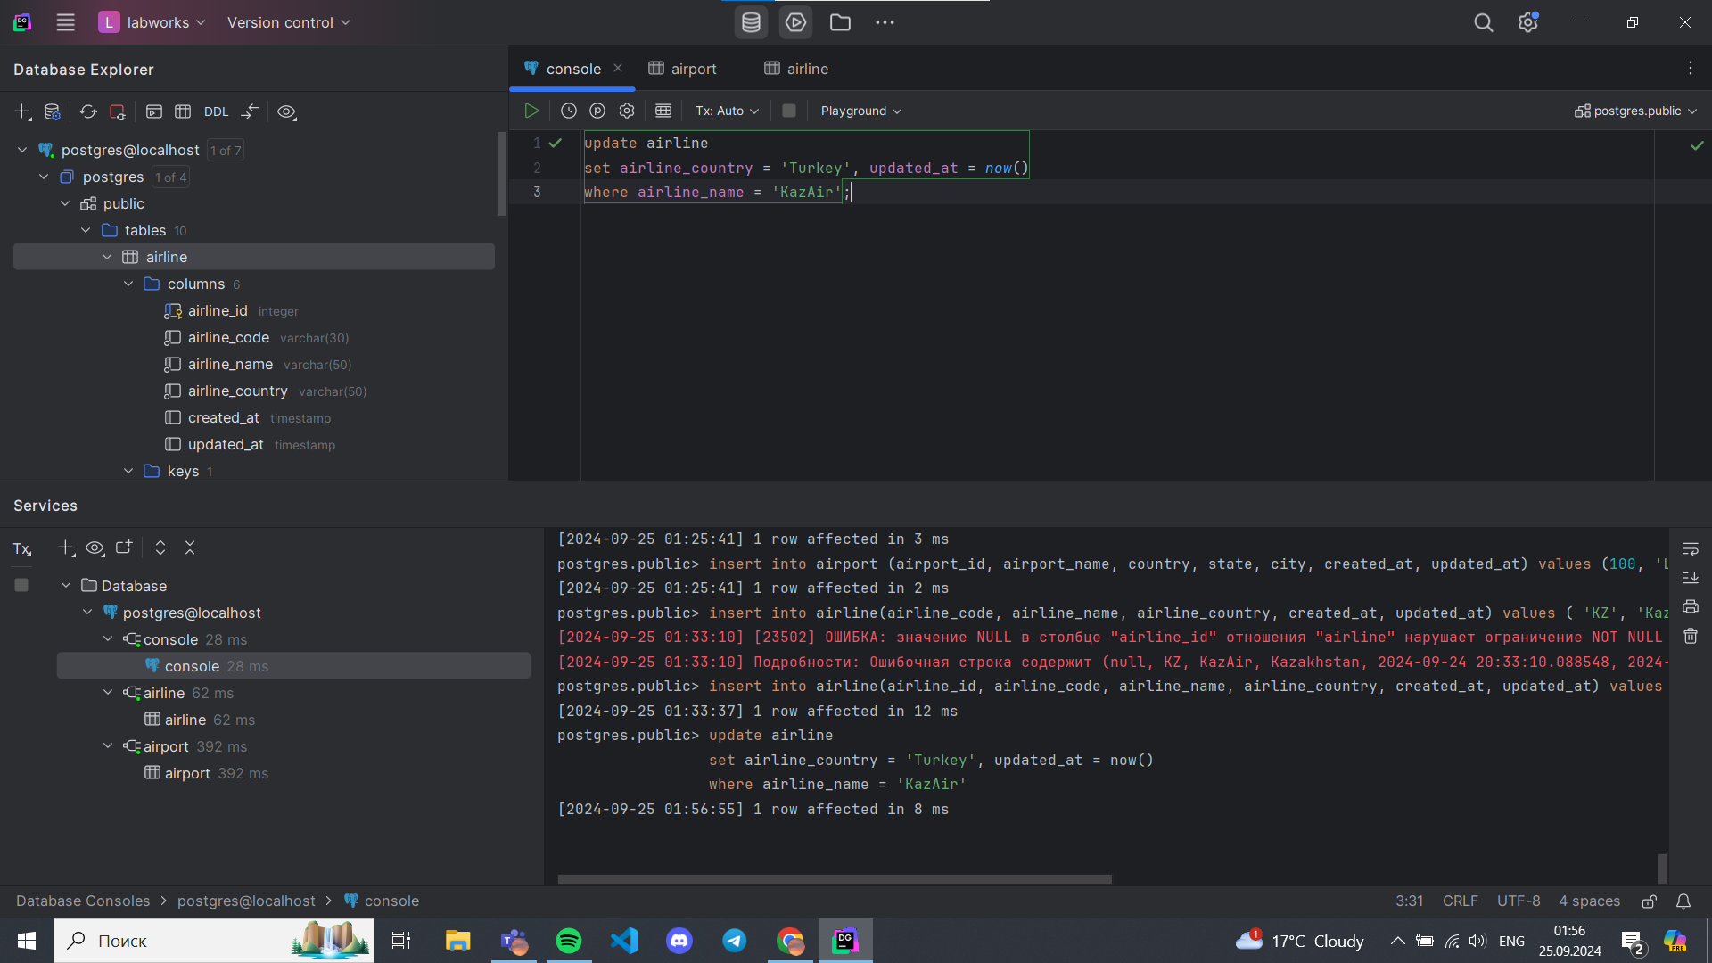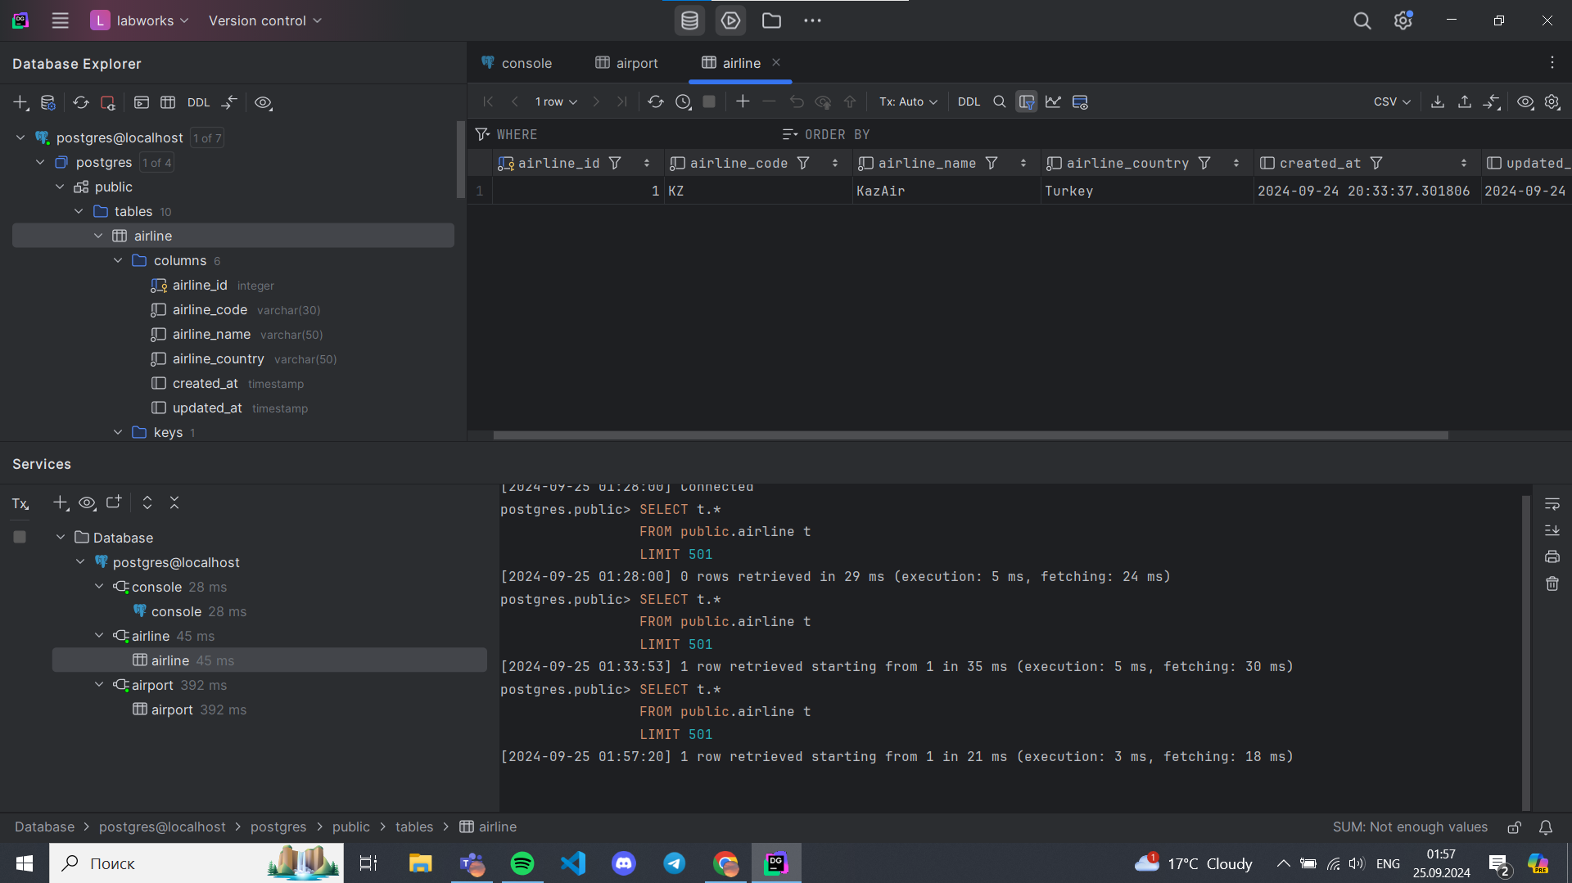
4. Remove the airline named "SIT" from the airline table. (**10%** )  
   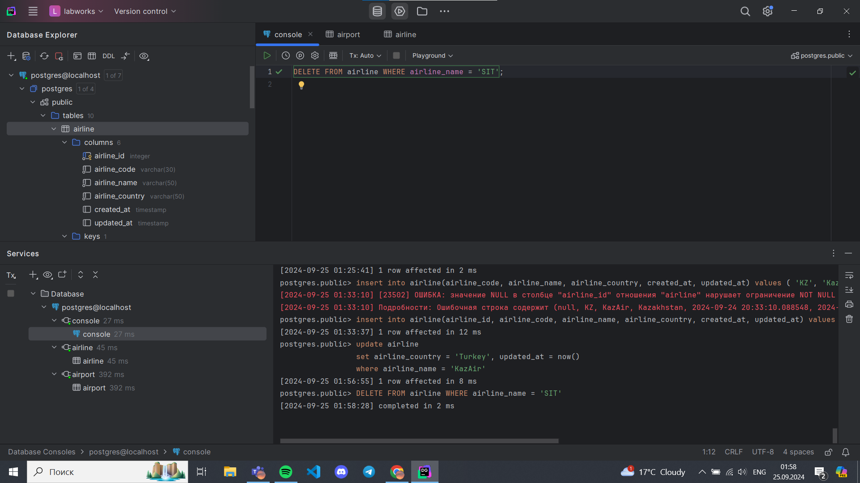
5. Add three airlines at once: "AirEasy" in "France", "FlyHigh" in "Brazil" and "FlyFly" in "Poland". (**10%** )  
     
   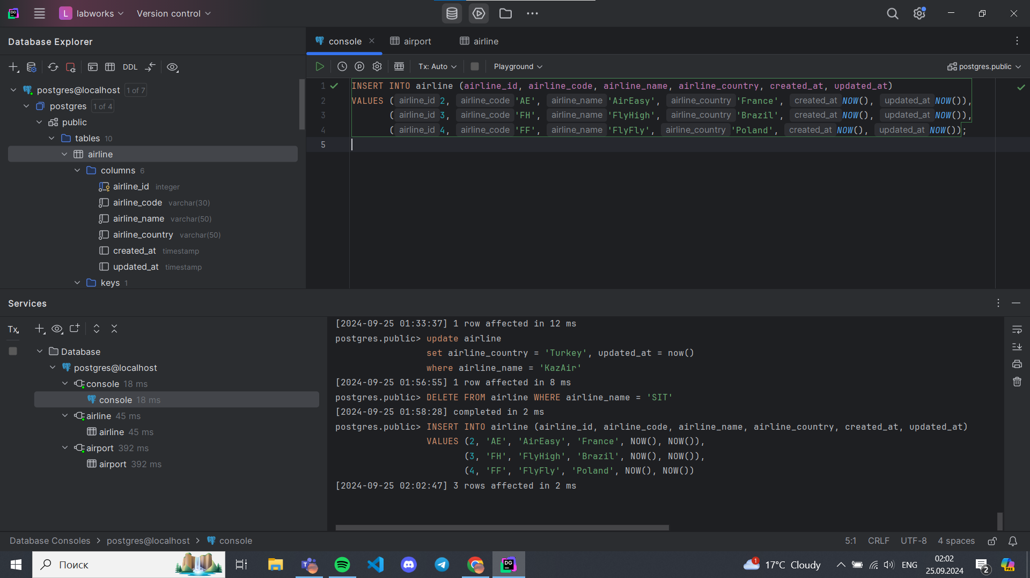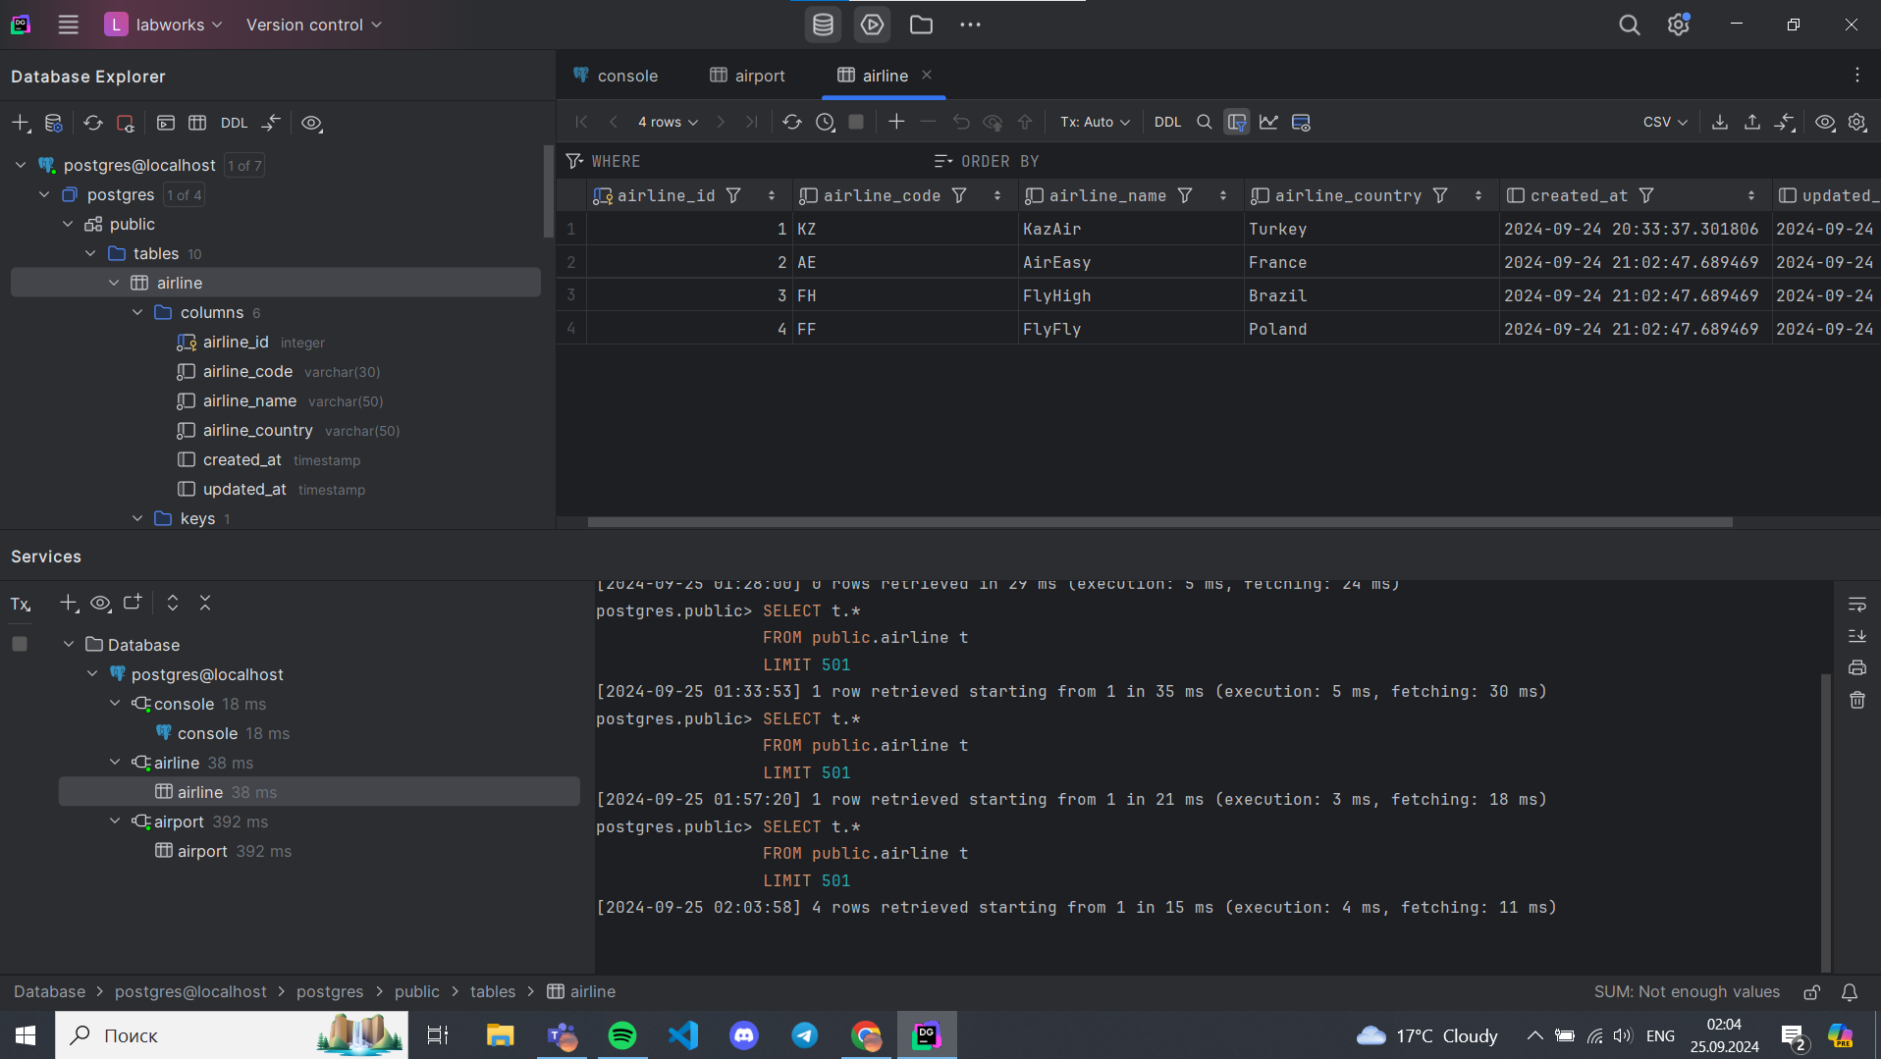
6. Delete all flights whose arrival in 2024 year. (**10%** )  
   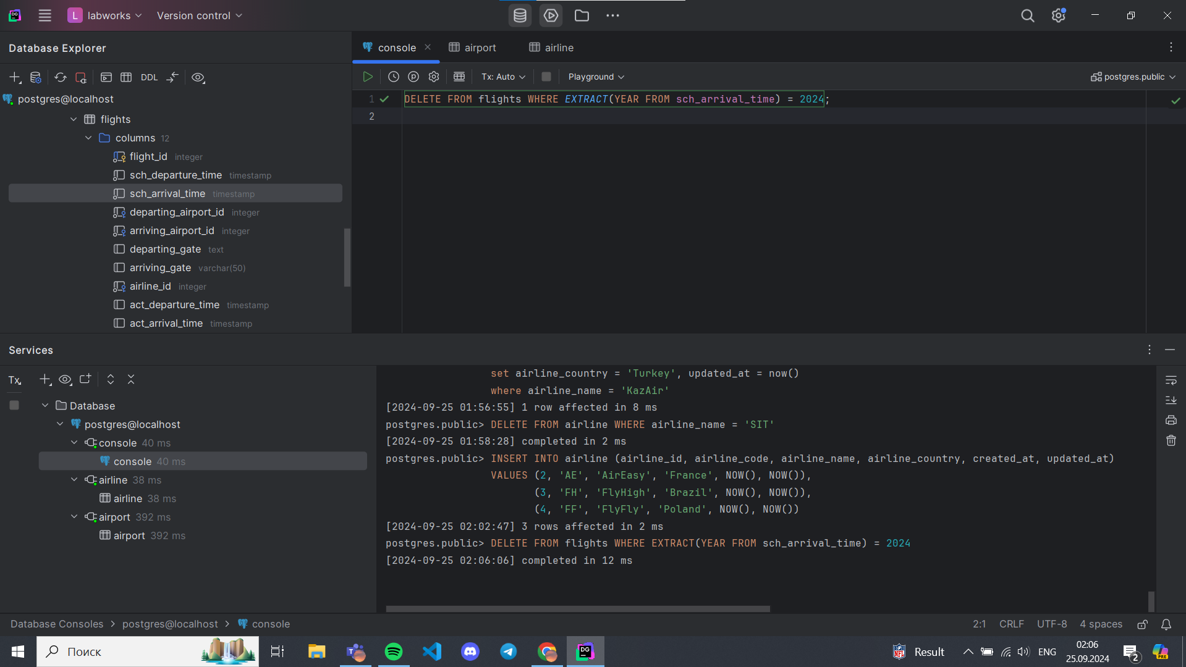
7. Increase the price of all tickets in booking table for flights by 10%.(**10%** )  
   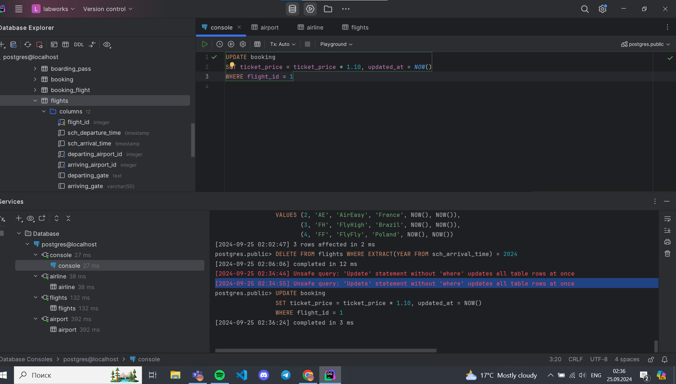
8. Delete all tickets whose price is less than 1000 units. (**10%** )  
   